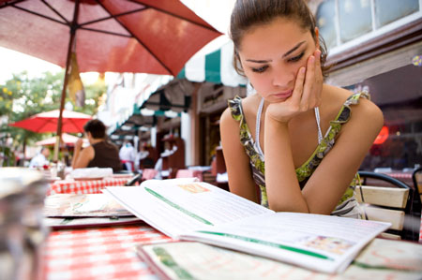

(A)  
(B)  
(C)  
**(D)**

2.



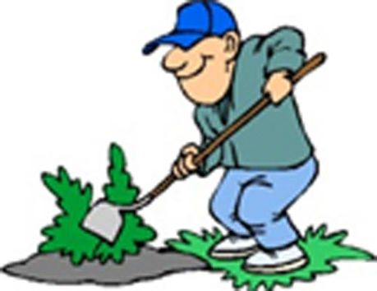

**(A)**

(B)

(C)

(D)

3.





(A)

**(B)**

(C)

(D)

4.



(A)

**(B)**

(C)

5.



(A)

(B)

**(C)**

6.



(A)

**(B)**

(C)

7.



(A)

(B)

**(C)**

8.



**(A)**

(B)

(C)

9.



**(A)**

(B)

(C)

10.



(A)

**(B)**

(C)

11.



**(A)**

(B)

(C)

12.



(A)

(B)

**(C)**

13.



(A)

**(B)**

(C)

14.



**(A)**

(B)

(C)



15. How many pens does the man need?

(A) 100

(B) 200

**(C) 300**

(D) 400

16. Why does he need the pens?

(A) To write a book

(B) For the office employees

(C) To make a large drawing

**(D) To give away at a conference**

17. How much will he pay for the pens?

(A) 20

(B) 40

**(C) 120**

(D) 140



18. According to the woman, what is the problem with the cleaner?

(A) Its shade is not right for her items

**(B) It is not solid enough to use**

(C) It is not convenient to apply

(D) It is more expensive than other brands

19. How did the woman learn about the item?

(A) From an advertisement

(B) From a product catalog

**(C) From some reviews**

(D) From her colleague

20. What does the woman say she would prefer?

(A) To get the money back

(B) To change the color

(C) To get a discounted item

**(D) To replace the item**